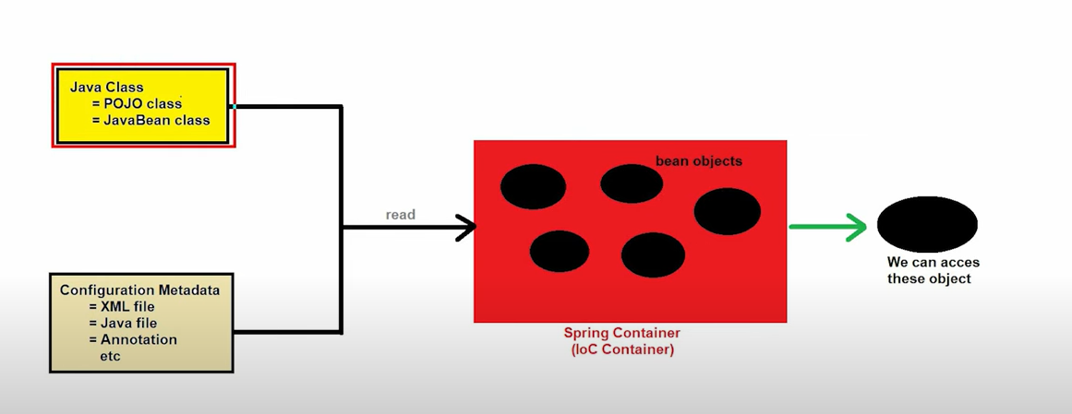

Life cycle
• Instantiation: The Spring container creates an instance of the bean.
Example: new Person()
• Properties Setting: The container injects values and dependencies into the bean’s properties.
Example: person.setName("Alice"); person.setAge(30);
• Initialization:
- The container applies any BeanPostProcessor callbacks before and after initialization.
- @PostConstruct or other custom initialization methods are called.
Example: person.initMethod() (if defined)
• Usage: The bean is fully initialized and ready for application use.
Example: Person person = context.getBean(Person.class);
• Destruction: When the container shuts down, any destruction methods, such as those annotated with @PreDestroy or custom methods, are called.
Example: person.destroyMethod() (if defined)

